**Call of war is too strong, son told pacifist Rowntree family before dying at Ypres**

**David Sanderson, Arts Correspondent**

January 4 2019, 12:01am, The Times

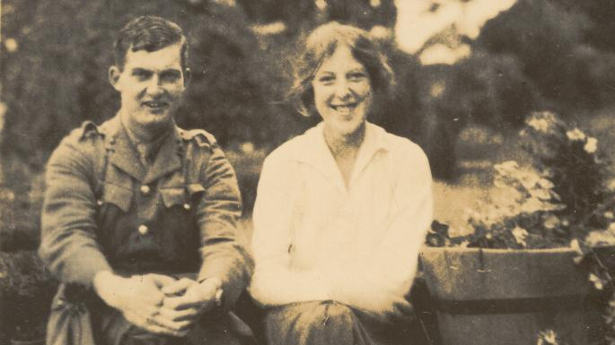

Lawrence Rowntree with his fiancée, Dorothy Cross, to whom he also wrote many letters

UNIVERSITY OF YORK

The letters of a Rowntree son who went to war despite his family’s pacifism have come to light a century after he died at Passchendaele.

Poignant notes from Lawrence Rowntree to his mother apologising for being an “awful disappointment” and explaining that the call of war was “too strong” are to go on display this year after being found by a great-niece. Lawrence, a grandson of Joseph Rowntree, the renowned Quaker businessman and, philanthropist, had joined the Friends’ Ambulance Unit when war broke out in 1914.

Sally-Anne Shearn, an archivist at the Borthwick Institute at York University, which is to provide access to the letters, said that Lawrence, a medical student, “wanted to make himself useful” when war began. “But within months it is clear that he is thinking he should be fighting,” Ms Shearn said. “He writes to his mother, who seems to be his chief confidant, in January 1916 saying that he has been ‘feeling a call’. He feels that he is doing easier work and, as somebody young, strong and healthy, he should be fighting.”

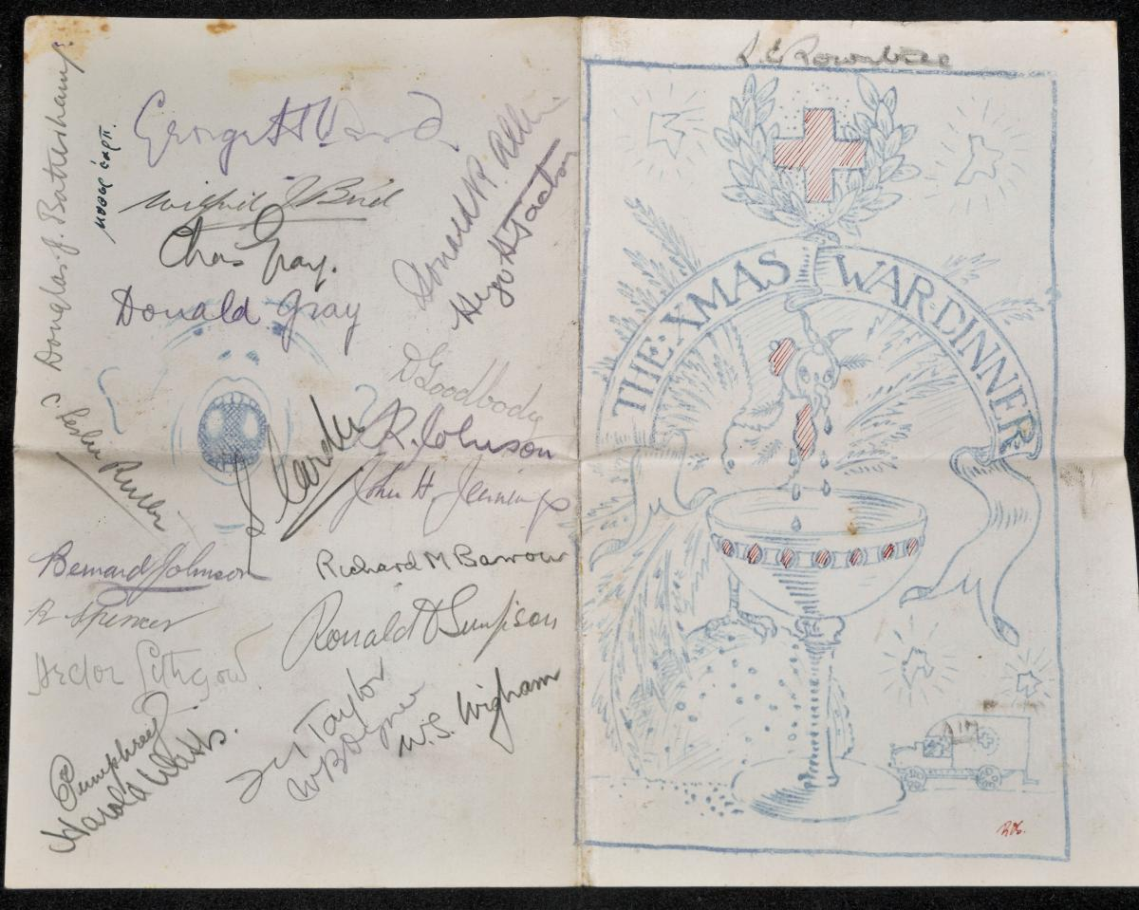

The letter in which Lawrence explains his reasons for joining the armyUNIVERSITY OF YORK

Lawrence’s dilemma came as his cousin Arnold Rowntree, MP for York, was campaigning for conscientious objectors to be allowed to abstain from the war.

In one letter to his mother, Constance, Lawrence apologises for his choice: “I know it is an awful disappointment to thee, & I have tried to fall in with what you would like, but the call is too strong. It doesn’t go against my conscience [to fight].”

Ms Shearn said that while Constance’s replies were lost, his letters suggested that she was supportive.

She added that the Rowntrees backed the war effort, turning factories into military hospitals and sending chocolates to the front. Lawrence joined C Company of what became known as the Tank Corps. He died aged 22 in November 1917 at the Third Battle of Ypres, also known as the Battle of Passchendaele.