A Stamp of Approval
Joseph Rowntree is one of six humanitarians being celebrated on a new set of Royal Mail stamps
York Quaker philanthropist and businessman, Joseph Rowntree, is one of six British Humanitarians to be named on a new set of Royal Mail Stamps that were issued on 15 March 2016 and available for twelve months. He was chosen to feature alongside two other men and three women for his dedication to improving the lives of people living in York, many of whom worked for his confectionery business, Rowntree & Co.

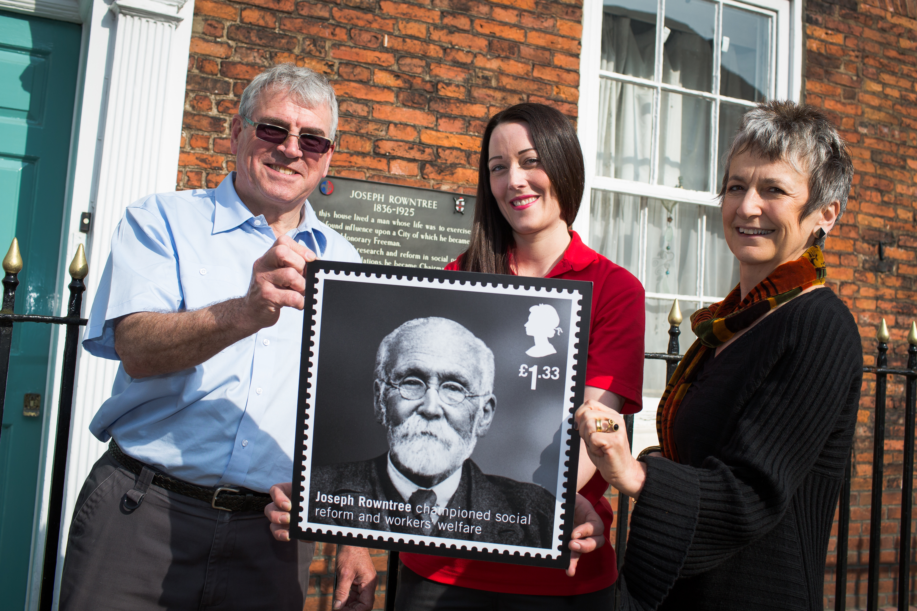© Royal Mail
Liz Grierson, Chair of the Rowntree Society, said:
‘The Royal Mail have given Joseph Rowntree a real 'stamp of approval' for his work and legacy by including him in the group of humanitarians honoured in this set of stamps. In his lifetime he worked hard to improve the life of his employees and the people of York. He created a factory with working conditions that presaged the welfare state, a model village (New Earswick) that has thrived for over a century, and a succession of schools, parks and theatres that continue to educate and entertain to this day.
With his wealth he established the Joseph Rowntree trusts that have taken forward his aim of a fair, democratic and peaceful society.
Joseph Rowntree was a humanitarian much admired for his work and vision and we hope the stamps will inspire interest and action in humanitarianism wherever they are sent.’
The new set of stamps, British Humanitarians, honours six individuals who have devoted their energies to helping and protecting others in the UK and abroad.
The other Humanitarians being honoured are John Boyd Orr, Josephine Butler, Sue Ryder, Eglantyne Jebb, and Nicholas Winton.
The stamps commemorate these individuals’ challenging of the causes of inequality, deprivation and ignorance, repairing shattered bodies and mind, and rescuing the vulnerable. They were driven human beings, sharing two significant characteristics – a natural concern for their fellow citizens of the world, and a single-minded desire to help those in need.

Joseph Rowntree: A brief biography
Born: 24 May 1836, York; Died: 24 February 1925, York.
Born into a prosperous and distinguished Quaker family in York, Joseph Rowntree was educated at Bootham School before starting a six-year apprenticeship at his father’s grocery store in 1852. After building up valuable business experience over the next few years, in 1869 he became a partner in his younger brother’s confectionery company where he helped to transform both the firm’s fortunes and, perhaps most significantly, the well-being of its employees, with the introduction of welfare programmes, medical services, pension schemes and sick benefits for the workforce.
“Healthful conditions are not luxuries to be adopted or disposed of at will,” he proclaimed. “They are conditions necessary for success.” But he also identified one remorseless enemy – “selfish and unscrupulous wealth.” Concerned that he was in possession of too much money, in 1904 he used half of his wealth to set up three trusts. The Joseph Rowntree Charitable Trust was created to give support to social research, adult education and the Society of Friends; the Joseph Rowntree Social Service Trust Ltd focused on social and political activities outside the strict definition of charitable work; and the Joseph Rowntree Village Trust had responsibility for building respectable but affordable housing for the working classes in the garden village of New Earswick in York and elsewhere. Joseph Rowntree gave these trusts discretion to adapt in response to changing circumstances over time, illustrating a favourite quotation of his that “time makes ancient good uncouth.”
The Quaker philanthropist rejected emotional responses to social crises. That there was poverty was obvious, Rowntree reasoned, but he wanted to identify the causes of such evils – and how they could be eliminated. There would ultimately be four trusts (Joseph Rowntree Charitable Trust, Joseph Rowntree Reform Trust, and the Joseph Rowntree Foundation/Joseph Rowntree Housing Trust). Their work, born in Edwardian England, resonates across time and space, far beyond Rowntree’s home city, and continues to this day. Adult education, research into social change, progressive housing – both in theory and in practice – became just part of the long and far-reaching legacy of Joseph Rowntree and his family.

Joseph’s humanitarian philosophy and his Memorandum
- In the writing of the ‘Founder’s Memorandum’ in 1904 for the establishment of the trusts in his name, Joseph Rowntree revealed his concerns for humanity and hopes for the future.
- Like many Quakers, he believed that people should not inherit great wealth, ‘…money is generally best spent by persons during their lifetime.’
- He was concerned about the appalling levels of poverty that marked Victorian and Edwardian society. His approach was unusual in that he highlighted a need to understand and tackle the root causes of poverty, not just treat its immediate symptoms.
- This was the essential message behind his famous Memorandum, ‘…much of the current philanthropic effort is directed to remedying the more superficial manifestations of weakness or evil, while little thought or effort is directed to search out their underlying causes.’
- Joseph Rowntree saw that more visible aspects of poverty were being alleviated by charities running soup kitchens and other services, but why were such services necessary in the first place? ‘The Soup Kitchen in York never has difficulty in obtaining adequate financial aid,’ he wrote, ‘but an enquiry into the extent and causes of poverty would enlist little support.’… ‘If the enormous volume of the philanthropy of the present day were wisely directed it would, I believe, in the course of a few years, change the face of England.’
Workforce Welfare
- Rowntree said ‘the real goal for an employer is to try and seek for others the fullest life of which an individual is capable.’
- Extraordinarily innovative working conditions introduced at Rowntree & Co included an eight hour day, a five-day working week, a pension scheme, works councils, a profit-sharing scheme, a resident doctor, dentist and a women’s officer, plus a range of educational programmes and leisure activities.
- As a factory owner, he saw that compassionate leadership and informed managerial organisation was the only way that underpaid working people could be more productive, achieve better wages, and escape poverty.
- There was thus a direct link between his views on poverty and social policy on the one hand and his views on business efficiency on the other.
- Fair treatment and loyalty also helped fulfil Quaker ideals of service to employees and consumers alike. ‘Employees should ‘never merely be regarded as cogs in an industrial machine, but rather as fellow workers in a great industry.’

Homes fit for Heroes
- Rowntree set up the Joseph Rowntree Village Trust in 1904, to build and manage the garden village of New Earswick, York. His purpose was to create an experimental village of improved housing for working people in York, based on the principles of the Garden Cities movement, ‘to improve the condition of working people’ and to provide them with ‘improved dwellings’ at affordable rents in a healthy environment.
- The New Earswick blueprint was to underpin Lloyd George’s promise to build Homes Fit for Heroes for returning soldiers after World War One.
- By 1904 there were 30 houses in New Earswick village; by 1954 there were nearly 630 residences of mixed tenure.
Refugees at New Earswick
- Joseph also had a strong European and international outlook. For example, he used the example of the state monopoly of the liquor trade in Sweden as a model which could be help to reduce alcohol abuse in Britain.
- Refugees fleeing from Belgium when World War One broke out were housed in New Earswick, and Joseph designated a number of houses specifically for this purpose. The houses were furnished by voluntary donations via a committee run through the Cocoa Works company.
Continuing relevance today
- The dictionary definitions of a Humanitarian apply perfectly to Joseph Rowntree as a person “Having regard to the interest of humanity or mankind at large … A philanthropist who goes to excess in his humane principles….Behaviour and disposition towards others as befits a man….Civil, courteous, obliging…Kind and benevolent.”
- Today, the religious terminology, the paternalism, the emphasis on family may resonate less, but the ideas of fairness, equality, community, reform and change still retain their power.
- There is still lively debate around the humanitarian questions that Rowntree raised in his own time. Workers’ welfare, the living wage, the impact of poverty in its moral context, the importance of good business practice, enlightened entrepreneurialism, lifelong education, good citizenship, adequate sustainable housing, democratic reform, and diversity in the press are very much part of contemporary debate.

Further information
See further www.rowntreesociety.org.uk. The Rowntree Society is a registered charity based in York that was founded in 2001 to further knowledge about the lives and legacy of the extraordinary Rowntree family over several generations. It acts as an information point, puts people in touch with each other, and advises on new projects and initiatives locally as well as nationally.

Bridget Morris, Executive Director, The Rowntree Society

